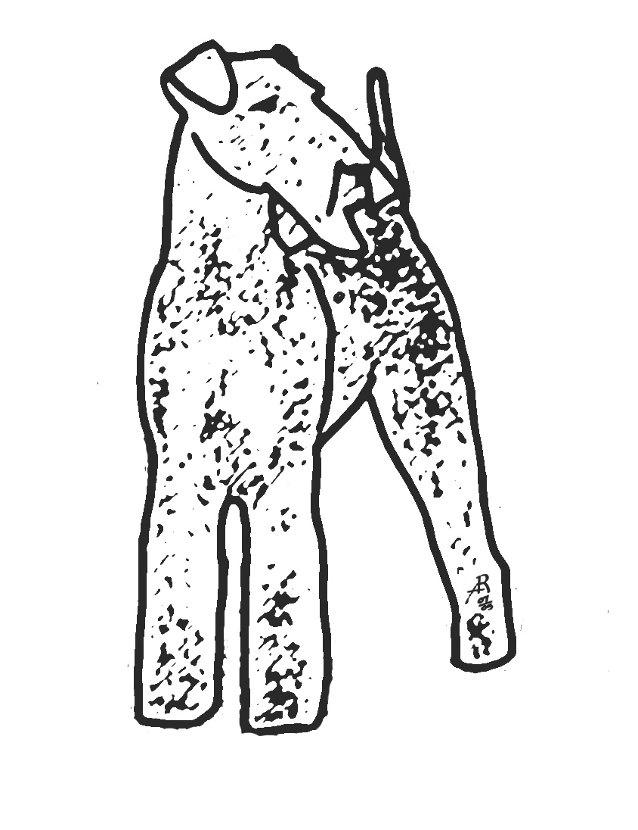Woodcrest Kennel LLC – where your dog is best in show
orford, new hampshire, usa, (603) 353-4720, www.woodcrestkennel.com

WAIT LIST QUESTIONNAIRE

Please fill out the following form, answerING ALL questions as completely as possible, SIGN YOUR NAME WHERE INDICATED, AND EMAIL TO DOGTALK@WOODCRESTKENNEL.COM :

NAME:
PHONE:
EMAIL:
ADDRESS:
CITY/STATE/ZIP:

TODAY’S DATE:

HOW DID YOU FIND US INITIALLY AND WHY DID YOU CHOOSE US OVER OTHER BREEDERS?

HAVE YOU BEEN REFUSED A PUPPY OR ADULT DOG OR OTHER ANIMAL FROM OTHER BREEDER(S)? IF YES, EXPLAIN.

HAVE YOU EVER RETURNED A PUPPY OR ADULT DOG OR ANY OTHER ANIMAL TO THE SELLER? IF YES, EXPLAIN.

HAVE YOU EVER GIVEN AWAY, SOLD, SURRENDERED TO RESCUE, OR OTHERWISE REMOVED A PUPPY OR ADULT DOG OR OTHER ANIMAL FROM YOUR HOUSEHOLD (FOR REASONS OTHER THAN PUTTING A SICK ANIMAL DOWN)? IF YES, EXPLAIN.

WHAT ARE YOU LOOKING FOR (ADULT / PUPPY, MALE / FEMALE, PET / SHOW QUALITY, WORKING AIREDALE, ETC.)?

ARE YOU LOOKING FOR THE FIRST AVAILABLE AIREDALE, NOT NECESSARILY FROM US?

WHAT IS YOUR EXPERIENCE WITH AIREDALES AND/OR TERRIERS AND/OR DOGS? IF YOU HAVE OWNED AIREDALES OR DOGS: PLEASE SPECIFY WHERE YOU GOT EACH FROM AND THEIR CONTACT INFO, PLEASE SPECIFY THE SPAY/NEUTERED STATUS OF THESE ANIMALS.

WHY ARE YOU INTERESTED IN THE AIREDALE TERRIER? WHAT DO YOU LIKE ABOUT THE BREED?

WHAT IS THE PERSONALITY AND ACTIVITY LEVEL OF THE DOG YOU ARE LOOKING FOR?

HAVE YOU EVER SHOWN A DOG IN AKC CONFORMATION? HAVE YOU EVER EXHIBITED A DOG IN OTHER AKC EVENTS? ARE YOU CONSIDERING PARTICIPATION IN THESE ACTIVITIES WITH YOUR NEW DOG? IF YES, EXPLAIN.

HAVE YOU EVER BEEN A BREEDER OR INVOLVED WITH THE BREEDING OF ANY ANIMALS OR THE SALE OF ANIMALS? HAVE YOU EVER CONSIDERED BREEDING ANIMALS OF ANY KIND? IF YES, EXPLAIN.

WHAT IS YOUR LIVING SITUATION (TYPE OF HOME, OWN/RENT, YEARS IN RESIDENCE, YARD, OCCUPATION/WORK FROM HOME/RETIRED, ALL OCCUPANTS OF HOUSEHOLD, KIDS, OTHER PETS, ETC.)?

WILL THE AIREDALE BE A MEMBER OF YOUR FAMILY?

WILL YOU CRATE TRAIN THE DOG?

HOW MUCH TIME WILL YOU SPEND WITH THE DOG PER DAY?

WILL YOU ENROLL IN PUPPY SOCIALIZATION/OBEDIENCE CLASSES?

WHAT TYPE OF GROOMING WILL YOU PROVIDE FOR THE DOG?

DO YOU AND/OR DOES ANY MEMBER OF YOUR HOUSEHOLD HAVE ALLERGIES OF ANY KIND? PLEASE LIST ALL ALLERGIES AND EXPLAIN.

DO YOU UNDERSTAND THE FINANCIAL AND PERSONAL COMMITMENT THAT IS INVOLVED IN OWNING A DOG? PLEASE DESCRIBE YOUR INTERPRETATION OF THESE COMMITMENTS.

OUR AIREDALES ARE SOLD WITH SPAY/NEUTER CONTRACTS AND AKC LIMITED REGISTRATION. DO YOU UNDERSTAND AND AGREE TO ABIDE BY THIS?

HAVE YOU READ AND DO YOU UNDERSTAND THE INFORMATION ON THE ‘FAQ & POLICIES’ PAGE OF OUR WEBSITE?

REFERRALS: PLEASE LIST THE NAME AND CONTACT INFO OF AT LEAST THREE (3) INDIVIDUALS WE CAN CONTACT WHO CAN TESTIFY TO YOUR APPLICATION. WE RECOMMEND: 1. YOUR VET, 2. YOUR GROOMER/BOARDING ESTABLISHMENT, 3. AN INDIVIDUAL WHO KNOWS YOUR HOUSEHOLD AND LIVING ARRANGEMENTS.

OUR PUPPIES AND ADULTS START AT $1800 WITH HALF DOWN AS A NON-REFUNDABLE DEPOSIT AT THE TIME WE OFFER YOU AN AIREDALE (IN THE CASE OF PUPPIES, THE DEPOSIT IS NOT DUE UNTIL AFTER THEY ARE BORN AND WE ARE SURE THAT WE HAVE ONE AVAILABLE FOR YOU) WITH THE REMAINDER DUE AT PICK UP. IS THIS PRICE WITHIN YOUR BUDGET?

WE ALWAYS RECOMMEND FINDING A BREEDER AS CLOSE TO YOUR OWN LOCATION AS POSSIBLE AND ARE ALWAYS HAPPY TO PROVIDE REFERRALS. WE PREFER TO WORK WITH PUPPY BUYERS IN THE NEW ENGLAND AREA (NH, VT, ME, MA, CT, RI, NY, NJ, PA, AND QUEBEC, CANADA). IF YOU ARE OUTSIDE THIS AREA WE WOULD LIKE TO KNOW, WHY DO YOU PREFER TO WORK WITH US RATHER THAN THOSE BREEDERS CLOSER TO YOU?

AFTER WE RECEIVE YOUR APPLICATION WE INVITE YOU TO COME FOR A VISIT TO MEET US AND OUR DOGS. PREFERENCE ON PLACEMENTS WILL GO TO THOSE WHO WE HAVE ALREADY MET IN PERSON. WE RECOMMEND THAT IT IS IN YOUR OWN BEST INTEREST TO VISIT ANY BREEDER YOU MIGHT GET A DOG FROM PRIOR TO COMMITING TO A PURCHASE FROM THEM. WHEN WOULD YOU LIKE TO SCHEDULE YOUR VISIT?

WHAT ARE YOUR QUESTIONS/CONCERNS?

OTHER NOTES/COMMENTS:

Please read thoroughly and print your full name where indicated:
We only breed healthy and conformationally correct Airedales with AKC Registration, OFA and/or PennHIP hip score Certification, and attaining AKC Championship Certification for the purpose of improving the breed. All our puppies are sold with spay/neuter agreements and AKC limited registration. We only have litters where we intend to keep at least one puppy (and often times multiple puppies) ourselves for show and to include in our breeding program in the future, which only benefits you and the quality of your pet Airedale. We provide those on our wait list with our best estimate of when we will have a puppy for them, however, please understand that many factors can change this estimate including whether a breeding takes and overall litter sizes. Being placed on our wait list does not guarantee that you will receive a puppy. You understand that one half of the purchase price of the puppy is considered as your non-refundable deposit. You agree to notify us if at any time you obtain an Airedale elsewhere or otherwise desire to be removed from our wait list. By submitting this application you agree that this application and its contents including your answers become the property of Woodcrest Kennel LLC and may be used as such provided that your personal contact information is not included in any public use. Woodcrest Kennel LLC is located in Orford, New Hampshire, USA.

Applicant, please print your full name here:
By typing your name, you certify that you have read and understand the paragraph above and that the information provided in this application is true and accurate.

